TYPES OF REACTION

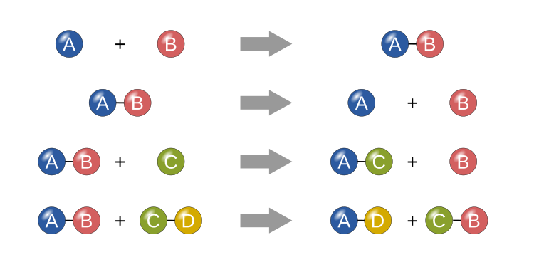

[This Photo](https://simple.wikipedia.org/wiki/Chemical_reaction) by Unknown Author is licensed under [CC BY-SA](https://creativecommons.org/licenses/by-sa/3.0/)

**1)** COMBINATION REACTION

**2)**DECOMPOSITION REACTION

b) decomposition reaction

c) decomposition reaction

**3)** DISPLACEMENT REACTION

**4)**DOUBLE DISPLACEMENT REACTION